https://shop.bbk.ru/products/mikrovolnovaya-pech-bbk-17mws-785s-w-belyiy-obieem-17-l-moshchnost-700-vt-avtomeny-blokirovka-ot-deteiy-funkciya-bystryiy-start-100992?yclid=7480214507316576255&ybaip=1
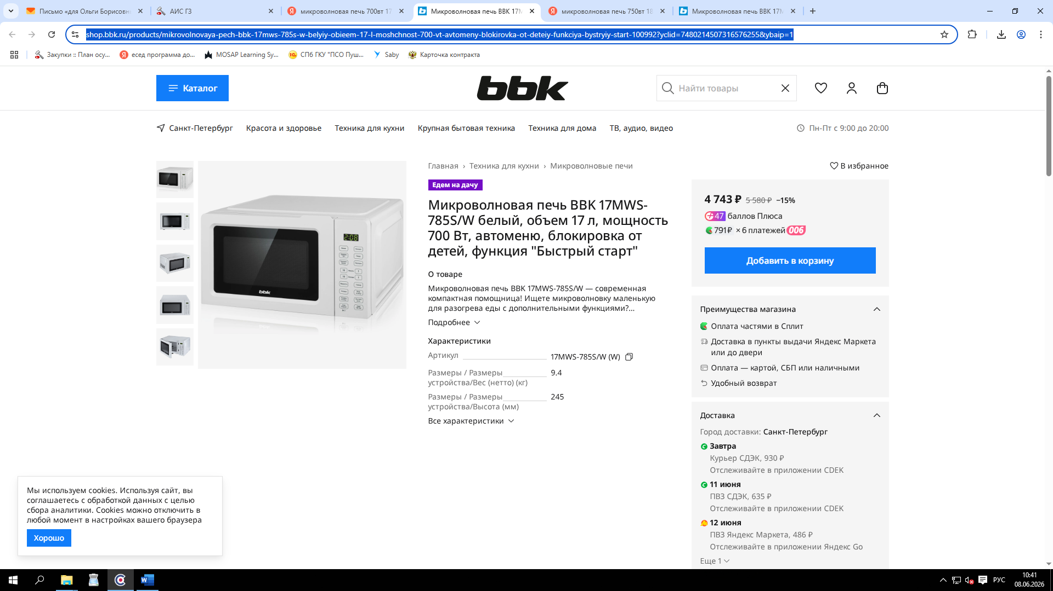
https://spb.poryadok.ru/catalog/mikrovolnovye_pechi/2095047/
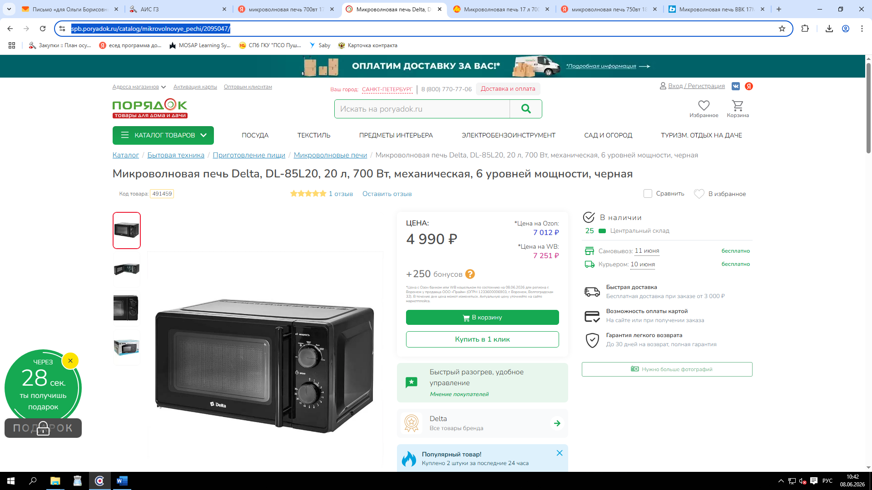

https://www.komus.ru/katalog/tekhnika/bytovaya-tekhnika/bytovaya-tekhnika-dlya-kukhni/prigotovlenie-pishhi/mikrovolnovye-pechi/mikrovolnovaya-pech-econ-eco-2038m-belaya/p/1716359/?from=block-123-0_1&qid=9168388853-0-1


